- Log-in to Cornerstone
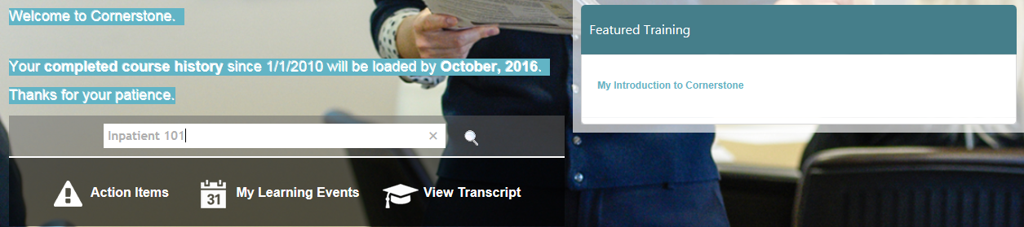

- Type “Inpatient 101” in search field
- Click the magnifying glass
- Locate Dallas0301- EPIC Inpatient- Inpatient 101 v3.0 and click on the title

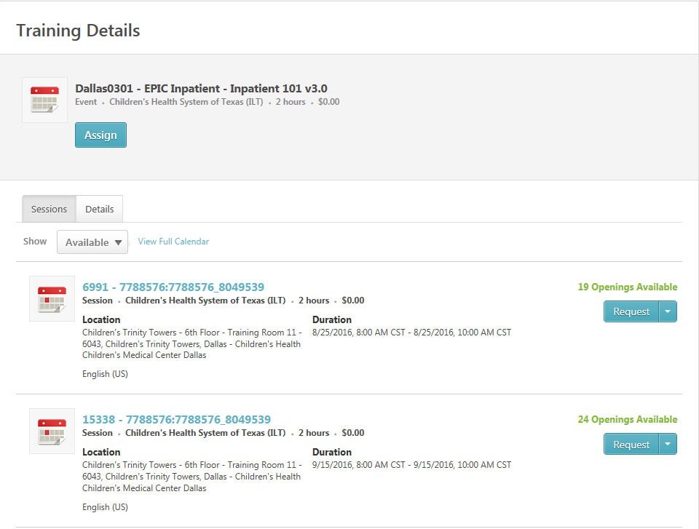
- Click Request to select desired available dates and times
- View Transcript to verify registration and Training Details.
